ASSINGMENT – 24

TO UPDATE THE VALUE USING PROCEDURE

To create a table:

Create table emp1(emp_id number,emp_name varchar(30),net_sal number)

Code:

create or replace procedure raise_sal(p_id in emp1.emp_id%TYPE,p_percent in number) is

begin

update emp1 set net_sal=net_sal*(1+p_percent/100) where emp_id=p_id;

end;

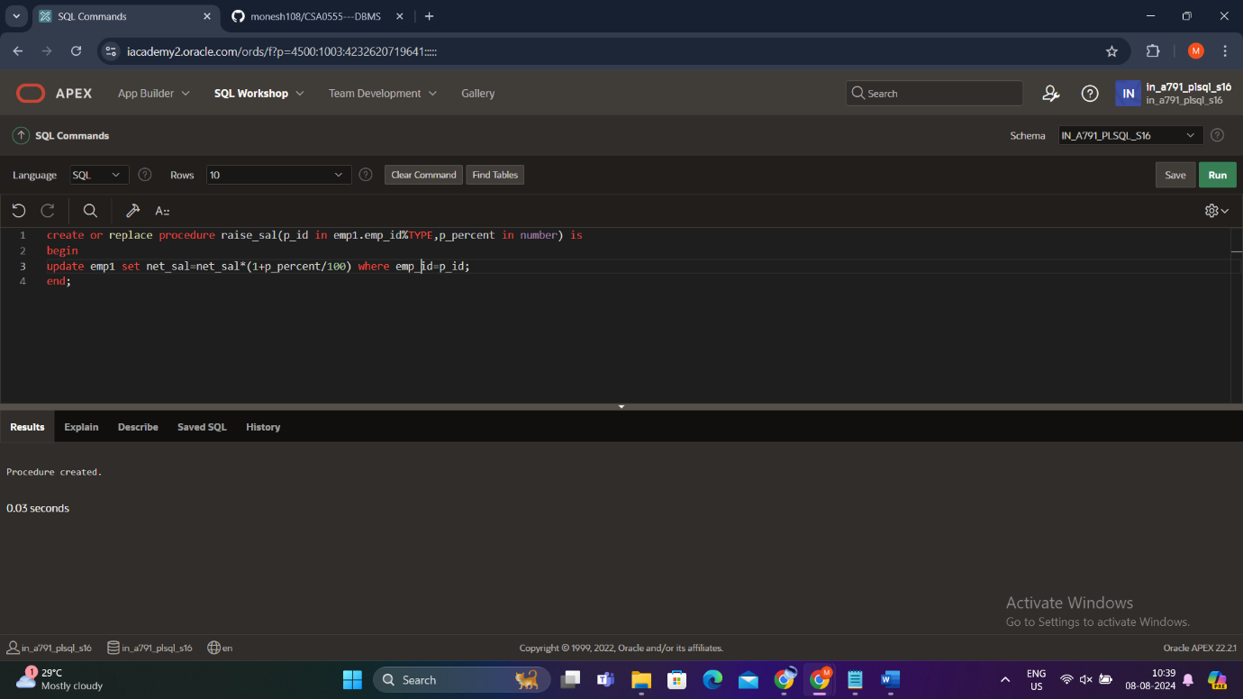

begin

raise_sal(103,10);

end;

/

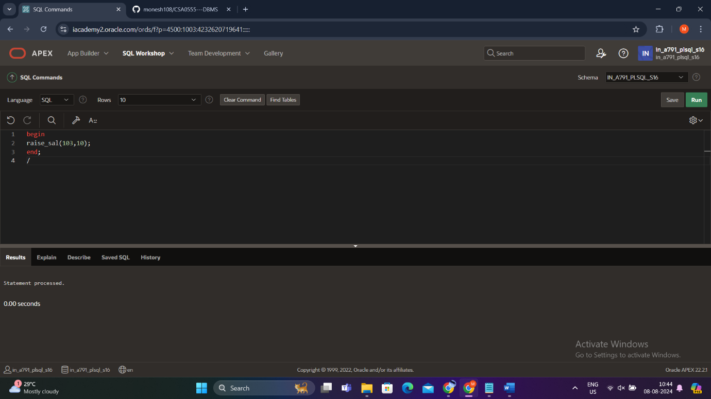

Output:

Select * from emp1;

